SASHA DUMARESQ
TRANSFORMATION COACH & CONSULTANT CAREER & CULTURE

BECOMING THE BEST VERSION OF YOU

Session 1: Introduction 2
Session 2: Boundaries 10
Session 3: Needs ₁₅
Session 4: Emotions 23

COPYWRITE TO SASHA DUMARESQ

How we show up today is relevant to the experience we will have. Below, let's make some personal commitments so you can maximise the experience of this mastermind.

Take 2 minutes to jot down your thoughts to these questions and we'll share our responses in breakout rooms.

What attributes will I bring to today’s mastermind?

What standards am I committing to?

What do I hope to experience in this mastermind?

WHEEL OF LIFE
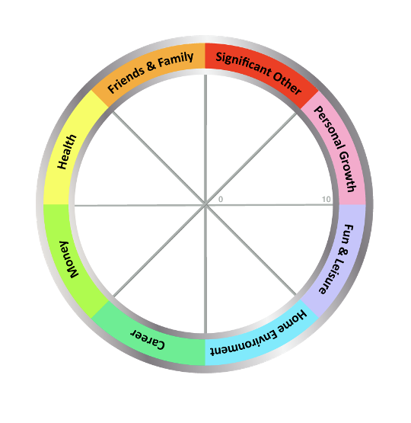

How do you feel in these different parts of your life?

Plot your satisfaction level for each of these by drawing a line across the segment, using the number indicator within the chart as your guide.

1 = Extremely Dissatisfied 10= Extremely Satisfied

Write the first number that you think of first, without overthinking it.

Where are you noticing in your life that needs your attention?

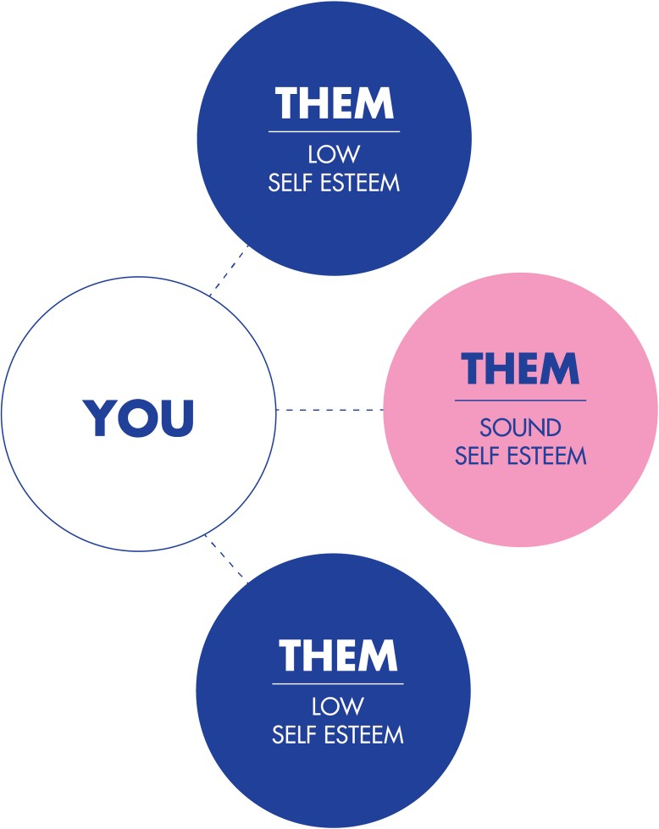

Low self esteem is when we see others as above AND below us.

Sound self esteem is where we see ourselves and others as equals, where each person is as relevant, important and unique, as each other.

"You alone are enough.
You have nothing to prove anybody"
- Maya Angelou

CREDIT TO THE COACHING INSTITUTE

The necessary elements of solid self esteem. This includes the ability to express them and ask for others to meet them.

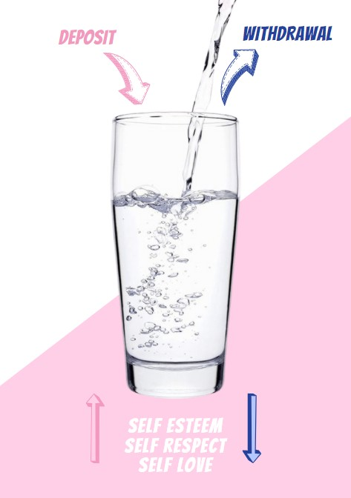

Where are you depositing? Where are you withdrawing?

BOUNDARIES

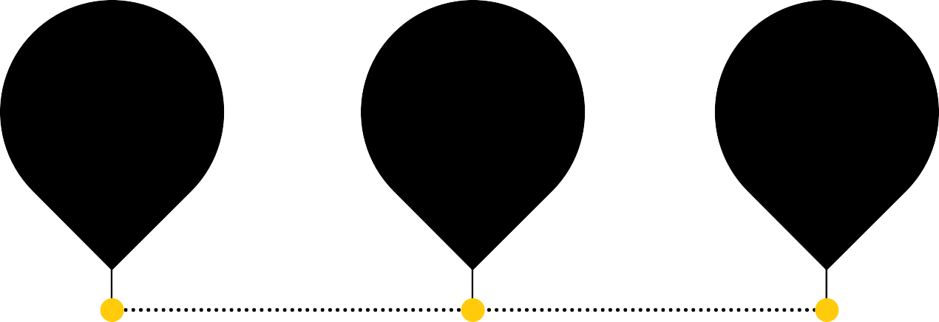
TOO STRONG
SOUND
TOO LAX
WITHDRAWAL DEPOSIT WITHDRAWAL

Boundaries are the invisible lines that signify where we end and another person begins. In between your line ending and another person's starting - is space. Space for each person to be their own entity with their own thoughts, feelings and ideas. This is having sound boundaries.

Often however, if we have lax boundaries those lines are joined to another and it's difficult to distinguish where you end and they start. This is called enmeshment - where there is no identifiable space between you. When too lax, boundaries are unclear and undefined and neither person knows how to operate as two distinct individuals.

When someone has very rigid or overly strong boundaries, those invisible lines become thick impenetrable walls. Here, there is rigidity of thought and of experiences - this person can be quick to shut things down. They can experience the world as unsafe and may use their rigid boundaries for self protection.

We can have different boundaries for different areas of our lives. Learning how to navigate these is key to the appropriate expression of your boundaries.

EXERCISE: PLOTTING YOUR BOUNDARIES

Looking at the different parts of your life, what are your current boundaries like? Where do they fall on the spectrum above? Plot them and write your answers below.

Work:

Home:

Significant Other:

Friends & Family:

Personal Growth:

Money:

Health:

Fun & Leisure:

How are your current boundaries, as identified above, helping your harming you?

What does it feel like when someone has crossed your boundary? Where do you feel it in your body?

How would you like your boundaries in the areas of your life to look and feel instead?

What do sound boundaries look like?

What do they feel like?

How will you know they're sound?

- Brene Brown
Daring to set boundaries is about having
the courage to love ourselves, even when we risk disappointing others

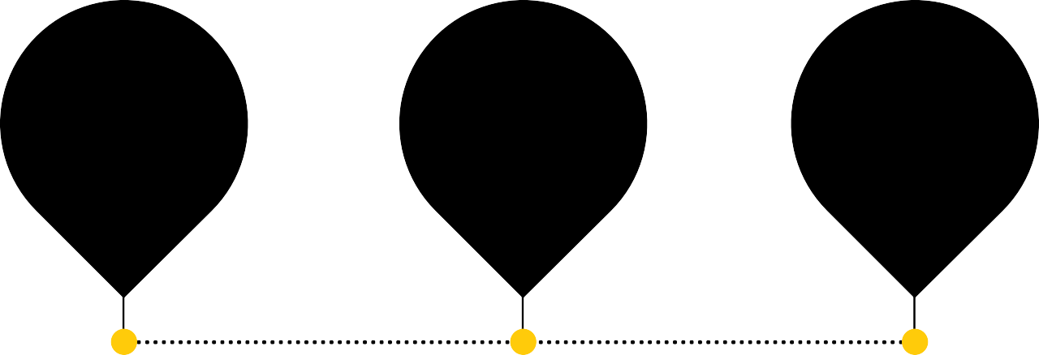
TOO MUCH
THEM
BALANCED
TOO MUCH
YOU
WITHDRAWAL DEPOSIT WITHDRAWAL

Needs, specifically emotional needs, are both universal and personal. Universal in that we as humans are social beings and we each require certain elements to be available to us so we feel satisfied in life. Personal, because we each have flavours of those needs and the expression of our needs can differ between people.

Some examples of universal needs are as follows (this list is not exhaustive): Emotional nourishment, intimacy & connection
To matter; to love and to belong Security, safety & stability Meaning & purpose
Progress & growth Boundaries and autonomy

When we are connected to ourselves, we have the ability and capability of meeting some of our own needs, while other needs will be met by the people around us. Becoming clear on how we can meet our own needs is important, as is being able to communicate our needs to others.

If we're overly needy in expecting others to meet our needs we may not recognise that we have the power and responsibility to do it ourself. This is when our needs fall into the "too much you" category. Alternatively, we may not know our needs nor have the ability to express them, and we overly meet others needs before our own. This is having "too much them" focus.

Like with many things, balance is key to our needs.

SASHA DUMARESQ 2020

CONNECTION

Acceptance Affection Appreciation Belonging Cooperation Communication Closeness Community Companionship Compassion Consideration Consistency Empathy Inclusion Intimacy
Love Mutuality Nurturing
Respect/Self=Res pect
Safety Security Stability Support
To know and Be Known
To see and Be Seen
To Understand and Be Understood Trust
Warmth

HONESTY

Authenticity Integrity Presence

PHYSICAL WELLBEING
Air Food
Movement/Exercise Rest/Sleep
Sexual Expression Safety Shelter Touch Water

PLAY

Joy Humor

AUTONOMY

Choice Freedom Independence Space Spontaneity

MEANING

Awareness Celebration of Life Challenge
Clarity Competence Consciousness Contribution Creativity Discovery Efficacy Effectiveness Growth
Hope Learning Mourning Participation Purpose
Self-Expression Stimulation To Matter
Understanding

PEACE

Beauty Communion Ease Equality Harmony Inspiration Order

What are your personal or internal needs you identified by the list above?

Which needs do you currently meet yourself?

Where in your life have you not been meeting your own needs?

Where do you consistently put others needs above your own? How would you like to change that?

Which needs do you ask others to meet?

What is a functional expression of your needs?

WHEN OUR NEEDS ARE SATISFIED

AFFECTIONATE

Compassionate Friendly Loving
Open hearted Sympathetic Tender

CONFIDENT

Empowered Open Proud Safe Secure

INSPIRED

Amazed Awed Wonder

JOYFUL
PEACEFUL

Calm Clear headed Comfortable
Centered Content Equanimous

Warm EXCITED
Beauty Communion
Fulfilled Mellow

ENRAGED

Absorbed Alert Curious Engrossed Enchanted Entranced Fascinated Interested Intrigued Involved Spellbound Stimulated

HOPEFUL

Expectant Encouraged Optimistic
Amazed
Animated Ardent Aroused Astonished Dazzled Eager Energetic Enthusiastic Giddy Invigorated Lively Passionate Surprised Vibrant

GRATEFUL

Appreciative Moved Thankful Touched
Ease Equality Harmony Inspiration Order

EXHILIRATED

Blissful Ecstatic Elated Enthralled Exuberant Radiant Rapturous

REFRESHED

Enlivened Rejuvenated Renewed Rested Restored Revived Thrilled

Quiet
Relaxed Satisfied Serene Still Tranquil Trusting
CREDIT TO THE COACHING INSTITUTE

AFRAID ANNOYED DISQUIET

Apprehensive Dread Foreboding Frightened Mistrustful Panicked Petrified Scared Suspicious Terrified Wary Worried

ANGRY
Enraged Furious Incensed Indignant Irate
Livid Outraged Resentful

EMBARRASED
Ashamed Chagrined Flustered Guilty Mortified
Self-conscious
Aggravated Dismayed Disgruntled Displeased Exasperated Frustrated Impatient Irritated Irked

AVERSION
Animosity Appalled Contempt Disgusted Dislike Hate Horrified Hostile Repulsed

CONFUSED
Ambivalent Baffled Bewildered Dazed Hesitant Lost Mystified Perplexed Puzzled Torn
Agitated Alarmed Discombobulat ed Disconcerted Disturbed Perturbed Rattled Restless Shocked Startled Surprised Troubled Turbulent Turmoil Uncomfortable Uneasy Unnerved Unsettled Upset

DISQUIET
CREDIT TO THE COACHING INSTITUTE
Alienated Aloof Apathetic Bored Cold Detached Distant Distracted Indifferent Numb Removed
Uninterested Withdrawn

FATIGUE SAD TENSE

Beat Burnt out Depleted Exhausted Lethargic Listless Sleepy Tired Weary Worn out
Depressed Dejected Despair Despondent Discouraged Disheartened Forlorn Heavy Hearted Hopeless Melancholy Unhappy Wretched
Anxious Cranky Distressed Distraught Edgy Fidgety Frazzled Irritable Jittery Nervous
Overwhelmed Restless Stressed Out
CREDIT TO THE COACHING INSTITUTE

VULNERABLE YEARNING

Fragile Guarded Helpless Insecure Leery Reserved Sensitive Shaky
Envious Jealous Longing Nostalgic Pining Wistful

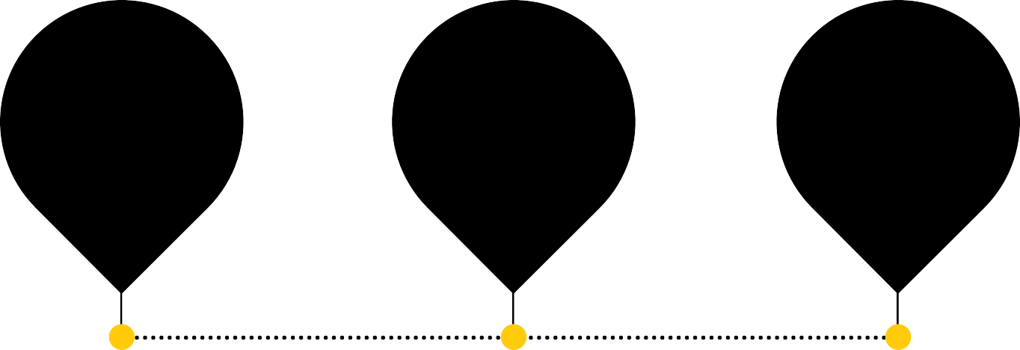
NOT EXPRESSING
APPROPRIATE EXPRESSION: PERSON PLACE
TIME
OVER EXPRESSING

WITHDRAWAL DEPOSIT WITHDRAWAL

Emotions can be described as a complex state of feeling.

There are hundreds of types of emotions each with their own energetic feeling and expression. Emotions can be described as light and shadow and some believe there are ‘positive’ and ‘negative’ emotions. However all emotions are valid, equal and necessary. Humans are designed to have and feel our emotions, yet so often we are taught to shut these down.

Sound emotional intimacy is where you are available and comfortable
within your emotional spectrum and can functionally and appropriately express all of your feelings.

When we overshare or are overly expressive of our emotions we blur the lines between our emotions and those of another.

Alternatively, when we shut down our emotions and do not express them at all, we are undervaluing ourselves and, essentially, our humanness.

EMOTIONS SCALE

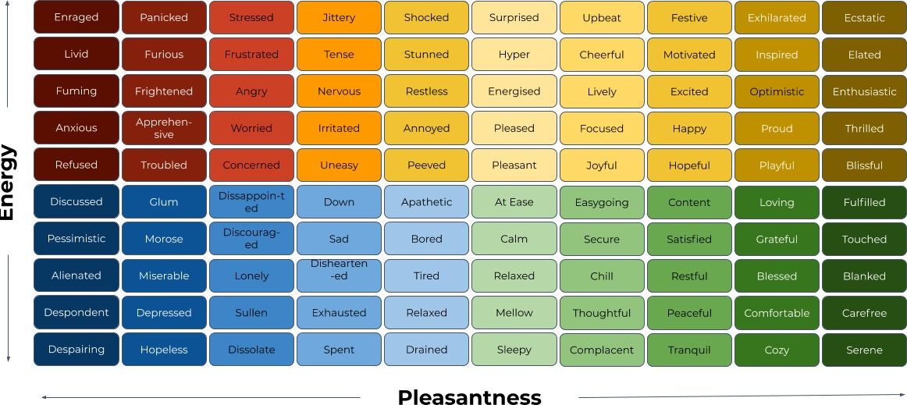

This scale will help you to drill into which emotions you are comfortable, and those you may not be - yet.
CREDIT TO THE COACHING INSTITUTE

EXERCISE

Have a look at the scale above to answer these questions.

Which emotions do you access easily?

Which emotions do you not access easily?

Which emotions are people around you encouraged to experience?

Which emotions are people around you discouraged to experience?

What do you do when someone expresses an emotion you’re not comfortable with?

What's the consequence of you not accessing all of your emotions?

NOTES

5 STEP PROCESS TO FEELING

Here's a simple but highly effective process to put YOU first in your day.

The most important connection we can have, yet a lot of us are missing it, is a connection to ourselves. We’ve been conditioned to focus outside of ourselves to others, and that any introspection can be deemed indulgent.

Doing this daily can build a deeper connection to your body and allows you to release any trapped or unexpressed emotions.

It is YOU giving space to YOU.

- Wake in the morning and before you even open your eyes, scan your body for any lingering emotions you have about something coming up for you that day, or from an event that happened the day before

- Where do you feel your emotions in your body? Can you detect an emotion lingering within you that you haven’t dealt with?

- Find the emotion and FEEL it. Intensify it and allow it to be there without judgement. Tell yourself it’s ok to feel that way and that it's perfectly normal and you are human after all!

- After a few moments of doing this, notice how you feel now.

Most often you will feel lighter, more connected and satisfied that the emotion you have been delaying or denying has been expressed.

Most importantly, you have connected head and heart and will start to build the muscle of both connecting inward and allowing your human emotions to be ok. Because they are and because YOU are.

- Brene Brown
We cannot selectively numb emotions.
When we numb the painful emotions we also numb the positive emotions.

Thank you!

I look forward to connecting with you!
Sasha Dumaresq
Transformation Coach
sasha@sashadumareq.com
linkedin.com/in/sasha-dumaresq

SASHA DUMARESQ

TRANSFORMATION COACH CAREER & CULTURE

